**NOT FOR NAVIGATION!! COURSES ARE APPROXIMATE!!**

**Course 4,** Clockwise. 8nm. start to mark 1 variable, mark 1 to 2 056°m mark 2 to 3 218°m, mark 3 to finish 124°m.

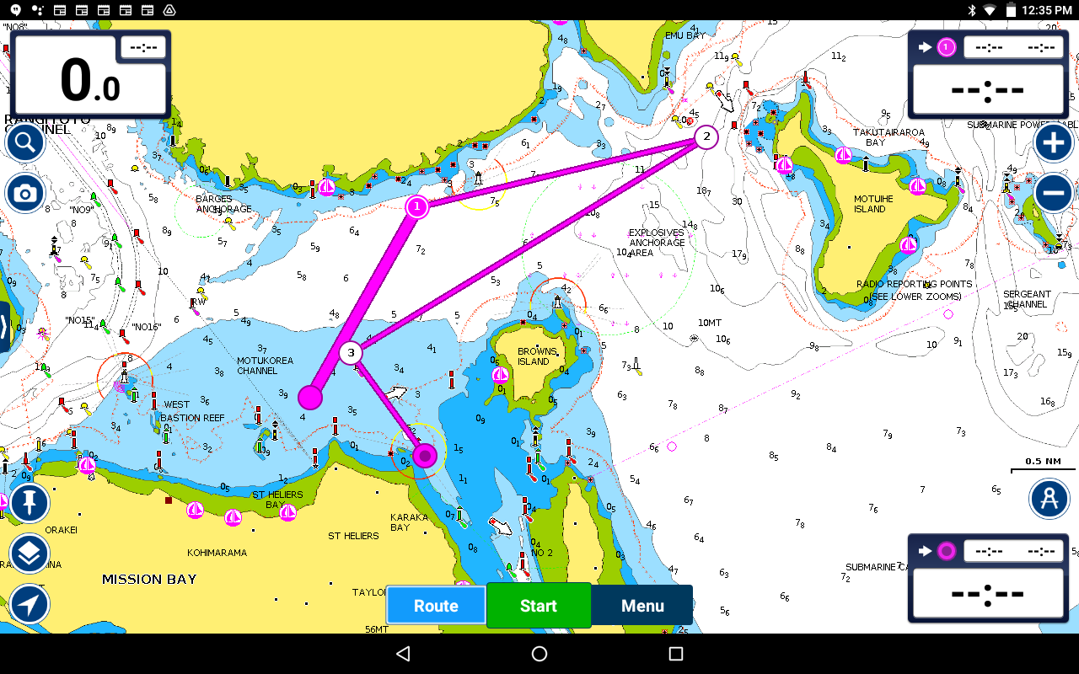

**Course 5, 2 laps clockwise.** 14.8nm. start to mark 1 variable, mark 1 to 2 003°m mark 2 to 3 057°m mark 3 to 4 218°m repeat second lap, mark 6 to finish 124°m.

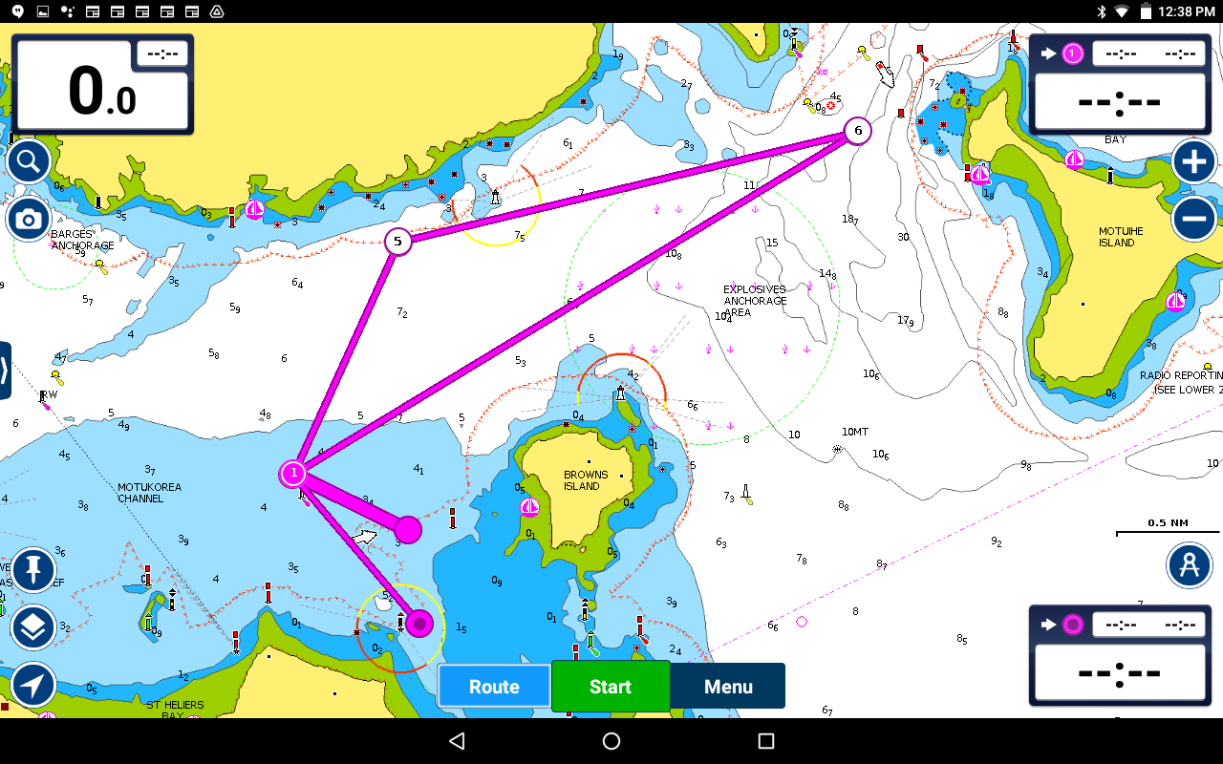

**NOT FOR NAVIGATION!! COURSES ARE APPROXIMATE!!**

**Course 6, clockwise.** 9.5nm. start to mark 1 variable, mark 1 to 2 008°m mark 2 to 3 057°m mark 3 to 4 176°m mark 4 to 5 291°m mark 5 to 6 291°m mark 5 to 6 235°m mark 6 to finish 124°m.

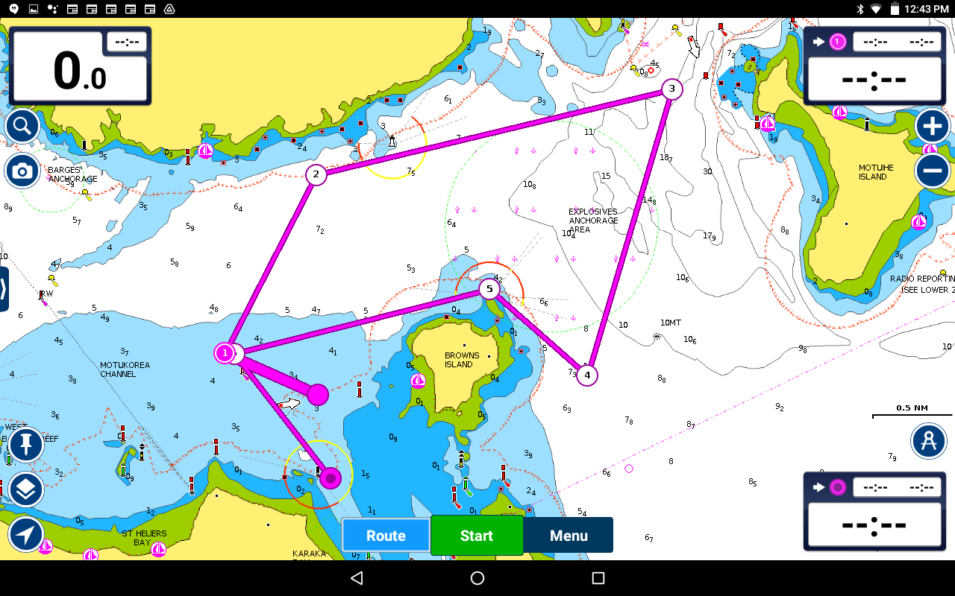

**Course 7, anti-clockwise.** 9.5nm. start to mark 1 variable, mark 1 to 2 055°m mark 2 to 3 113°m mark 3 to 4 357°m mark 4 to 5 291°m mark 5 to 6 235°m, mark 6 to finish 124°m.

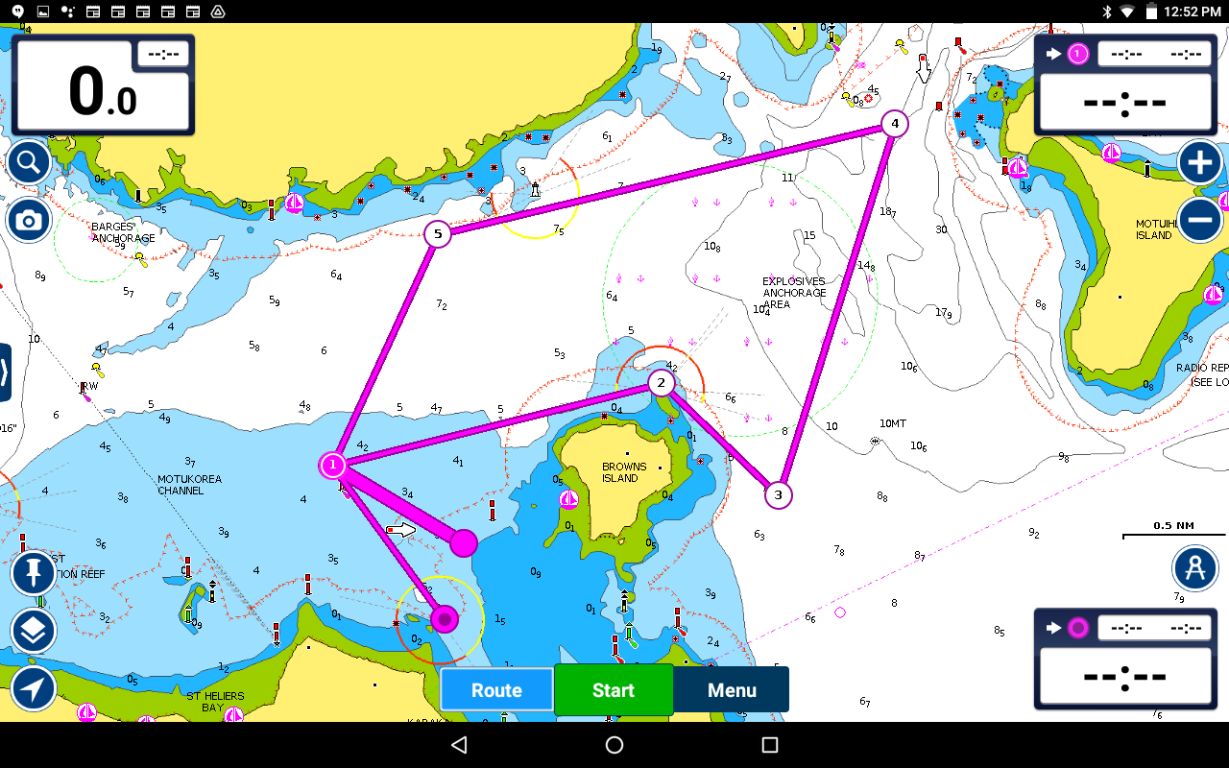

**NOT FOR NAVIGATION!! COURSES ARE APPROXIMATE!!**

**Course 8,** 9.8nm. start to mark 1 variable, mark 1 to 2 296°m mark 2 to 3 065°m mark 3 to 4 231°m mark 4 to 5 073°m.

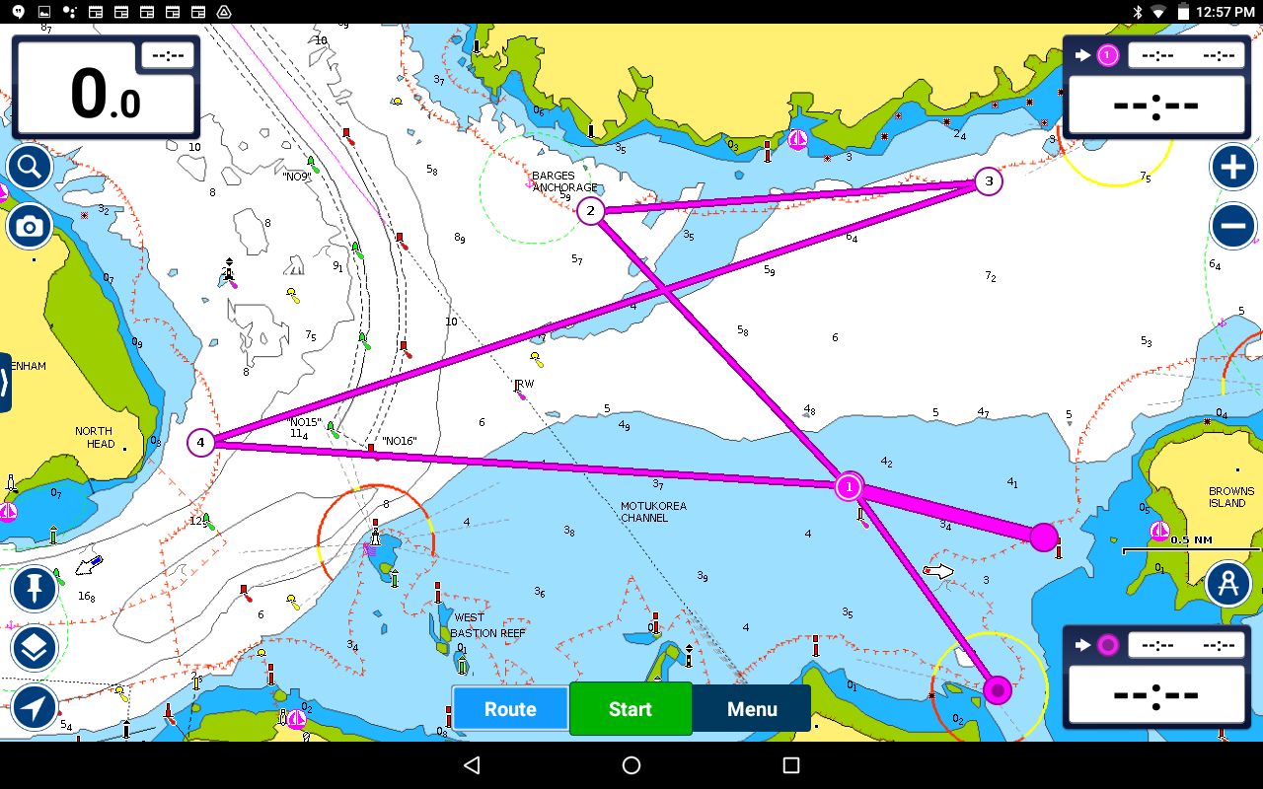

**Course 9,** 9.7nm. start to mark 1 variable, mark 1 to 2 253°m mark 2 to 3 051°m mark 3 to 4 245°m mark 4 to finish 120°m.

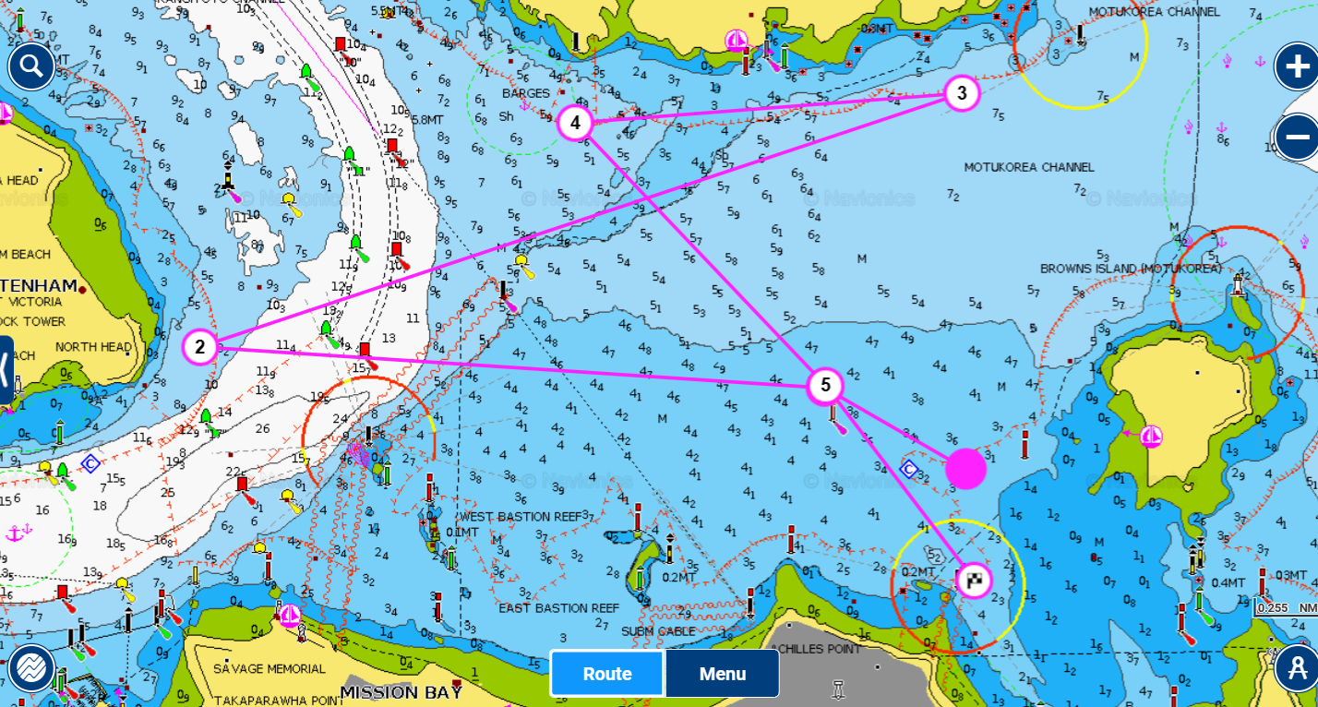

**NOT FOR NAVIGATION!! COURSES ARE APPROXIMATE!!**

**Course 10,** 8.8nm. start to mark 1 variable, mark 1 to 2 055°m mark 2 to 3 113°m mark 3 to 4 293°m mark 4 to 5 250°m mark 5 to 6 092°m.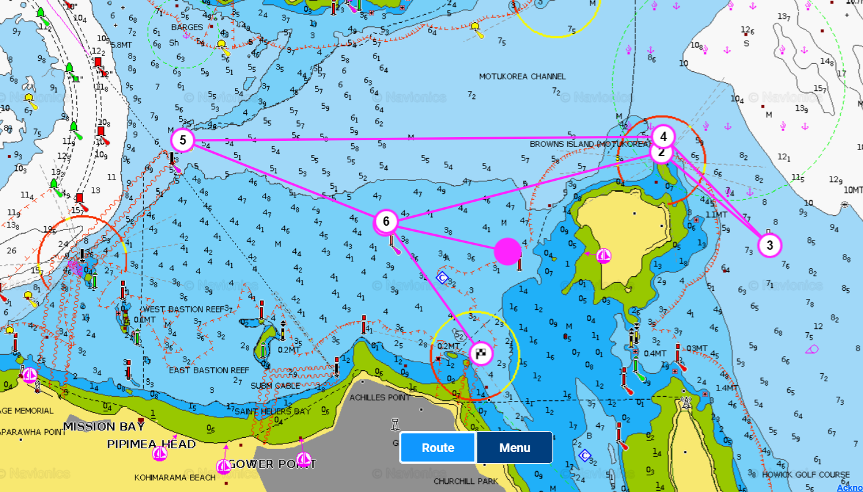

**Course 11, anti-clockwise** 7.1nm. start to mark 1 variable, mark 1 to 2 001°m mark 2 to 3 234°m mark 3 to 4 085°m mark 4 to 5 001°m mark 5 to finish 119°m

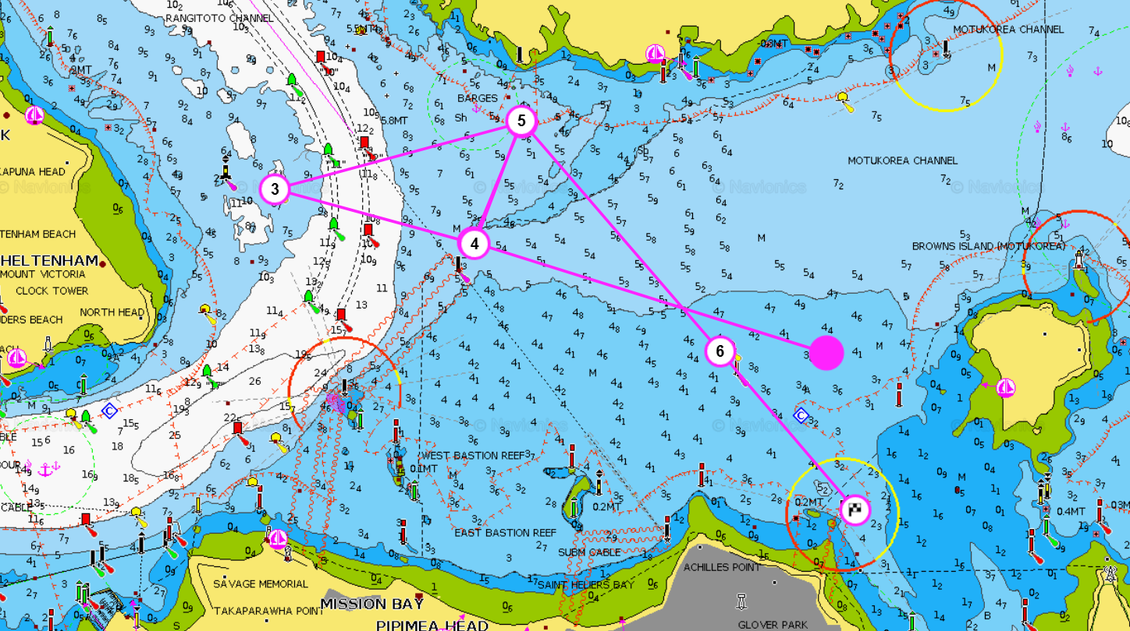

**NOT FOR NAVIGATION!! COURSES ARE APPROXIMATE!!**

**Course 12,** 9.4nm. start to mark 1 variable, mark 1 to 2 269°m mark 2 to 3 008°m mark 3 to 4 275°m mark 4 to 5 104°m mark 5 to finish 124°m.

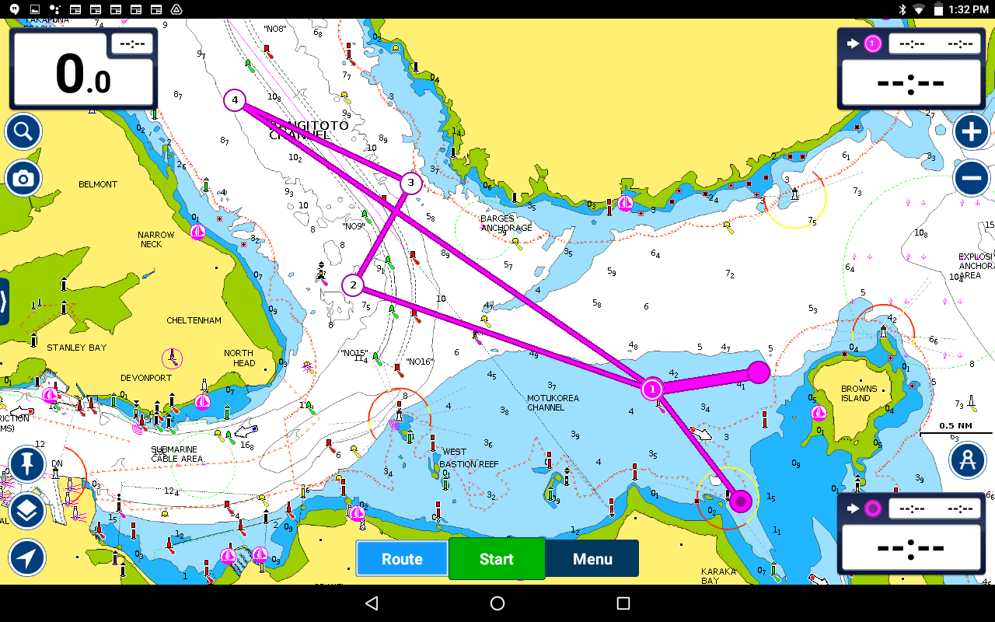

**Course 13,** 9.1nm. start to mark 1 variable, mark 1 to 2 083°m mark 2 to 3 109°m mark 3 to 4 289°m mark 4 to 5 204°m mark 5 to 6 183°Mmark 6 to finish 124°m.

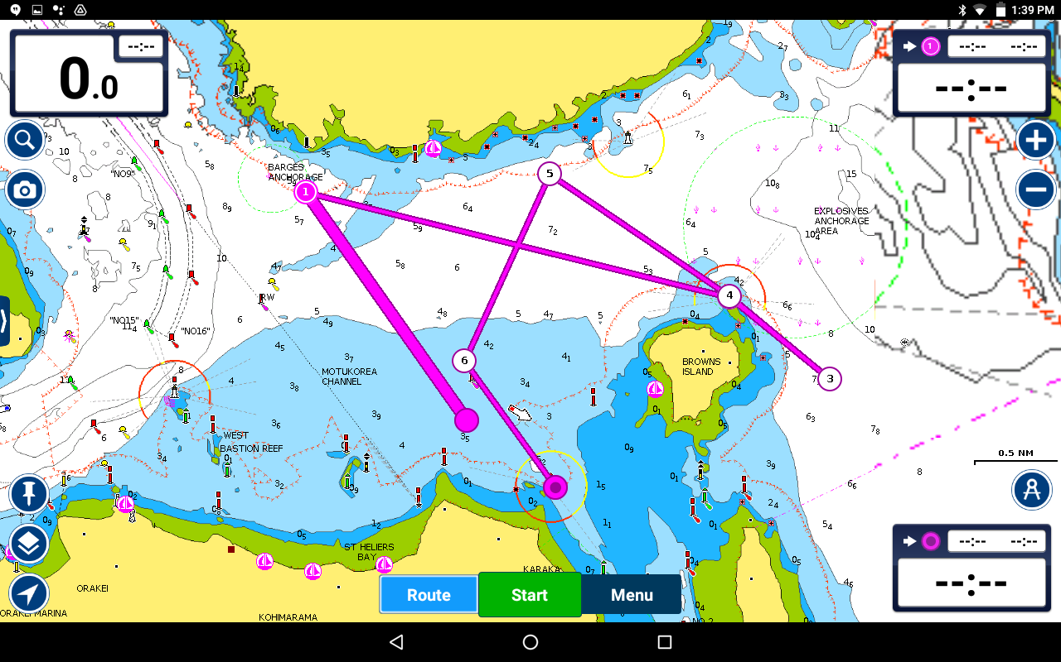

**NOT FOR NAVIGATION!! COURSES ARE APPROXIMATE!!**

**Course 14,** 9.9nm. start to mark 1 variable, mark 1 to 2 290°m mark 2 to 3 132°m mark 3 to 4 048°m mark 4 to 5 183°m mark 5 to 6 003°m.

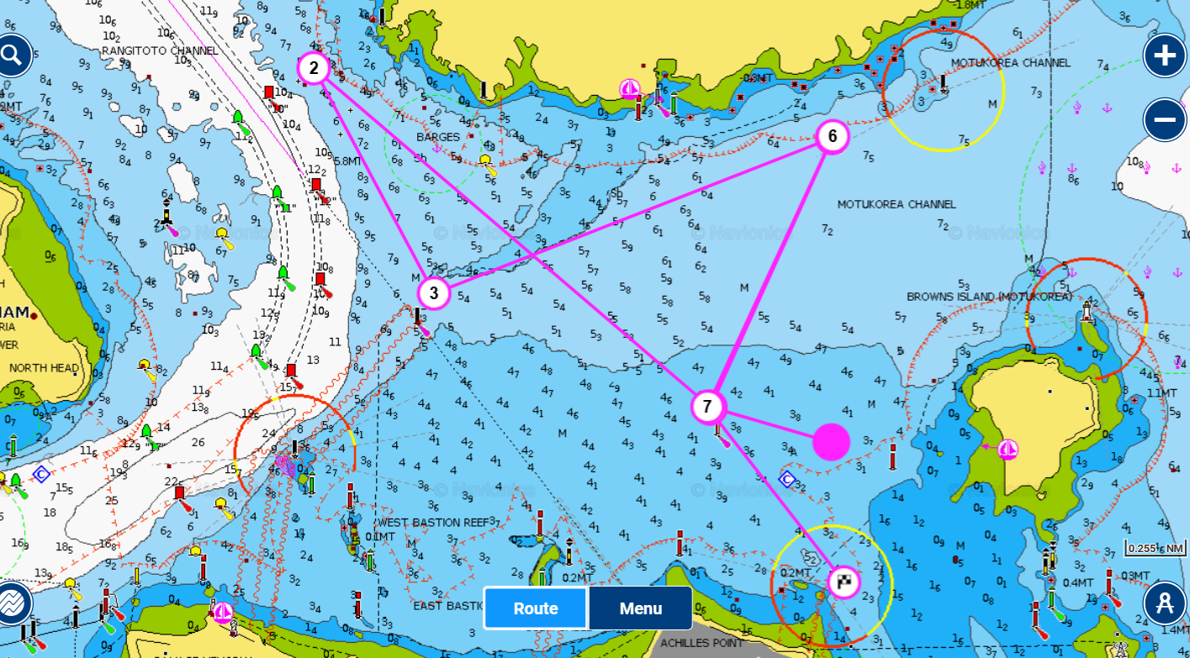

**Course 15, Anti-clockwise,** 6 nm. start to mark 1 variable, mark 1 to 2 004°m mark 2 to 3 065°m mark 3 to 4 117°m mark 4 to finish.

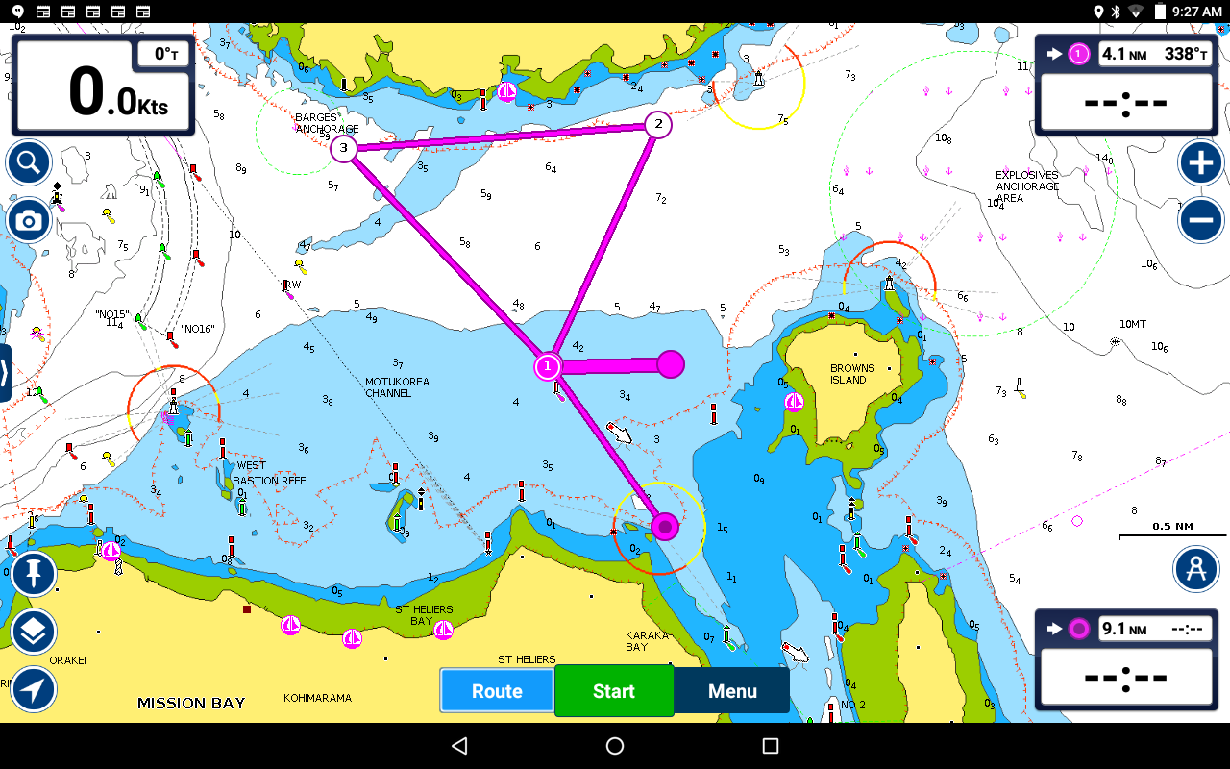

**NOT FOR NAVIGATION!! COURSES ARE APPROXIMATE!!**

**Course 16, clockwise,** 9.8nm. start to mark 1 variable, mark 1 to 2 004°m mark 2 to 3 056°m mark 3 to 4 177°m mark 4 to 5 290°m mark 5 to 6 285°m mark 6 to 7 186°m to finish.

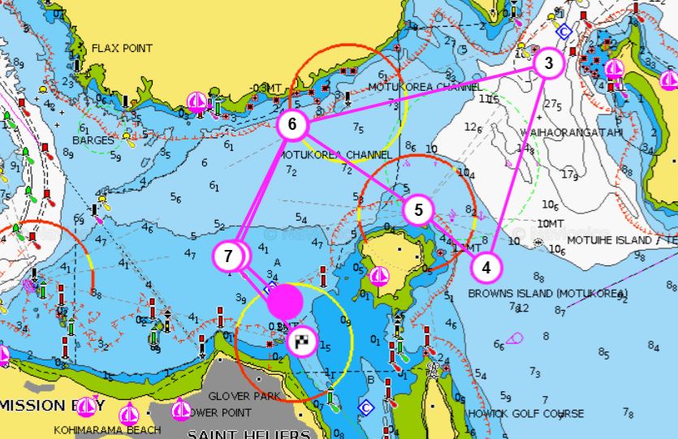

**Course 17,** 8.1nm. start to mark 1 variable, mark 1 to 2 004°m mark 2 to 3 102°m mark 3 to 4 112°m mark 4 to 5 292°m mark 5 to 6 282°m mark 6 to 7 184°m mark 7 to finish.

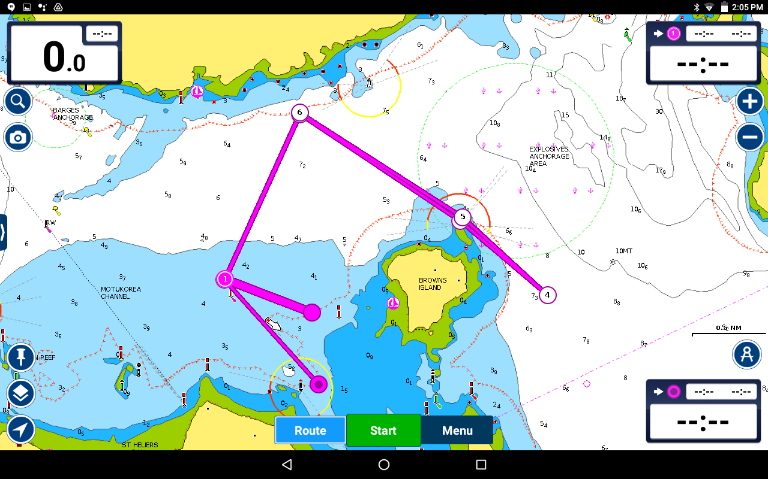

**NOT FOR NAVIGATION!! COURSES ARE APPROXIMATE!!**

**Course 18, Anti-clockwise 2 laps,** 9.6nm. start to mark 1 variable, mark 1 to 2 004°m mark 2 to 3 245°m mark 3 to 4 116°m mark 4 to 5 204°m mark 5 to 6 245°m mark 6 to finish 116°m.

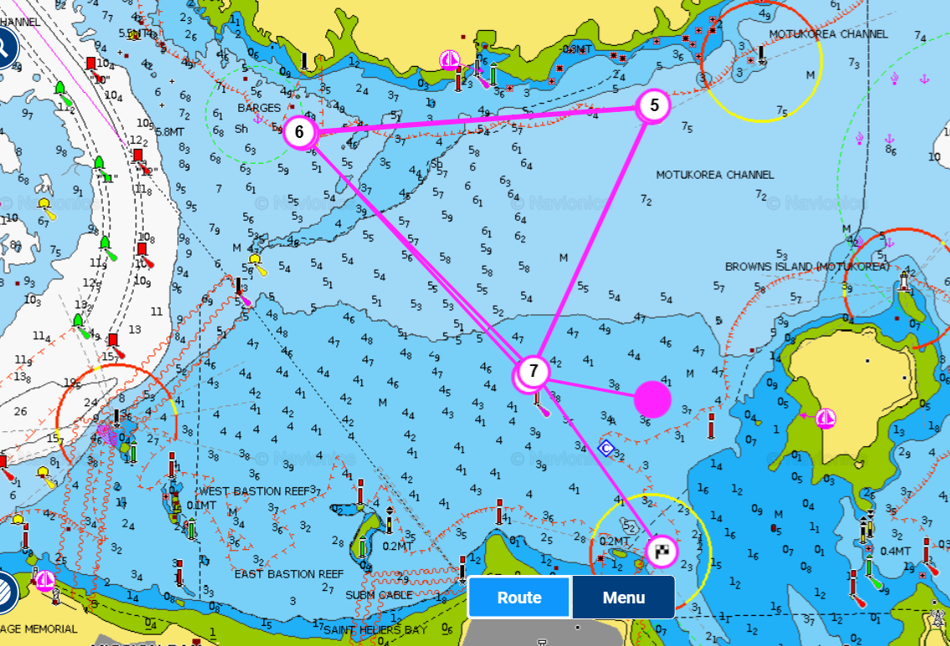

**Course 19, Clockwise 2 laps,** 9.6nm. start to mark 1 variable, mark 1 to 2 297°m mark 2 to 3 065°m mark 3 to 4 184°m mark 4 to 5 297°m mark 5 to 6 065°m mark 6 to 7 184°m to finish.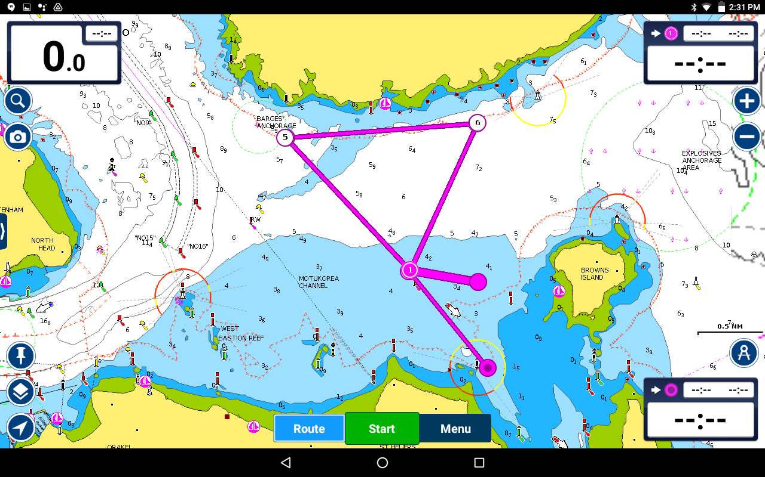

**NOT FOR NAVIGATION!! COURSES ARE APPROXIMATE!!**

**Course 20,** 17nm. start to mark 1 variable, mark 1 to 2 038°m mark 2 to 3 177°m mark 3 to 4 289°m mark 4 to 5 284°m mark 5 to 6 231°m mark 6 to 7 039°m mark 7 to 8 117°m mark 8 to 9 004°m mark 9 to 10 186°m to finish.

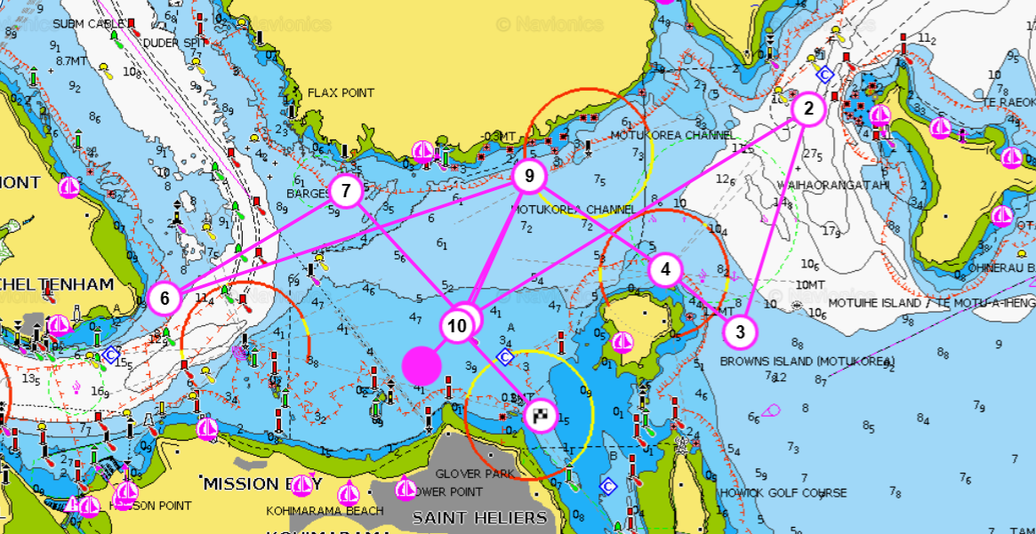

**Course 21,** 11.5nm. start to mark 1 variable, mark 1 to 2 293°m mark 2 to 3 167°m mark 3 to 4 347°m mark 4 to 5 113°m to finish.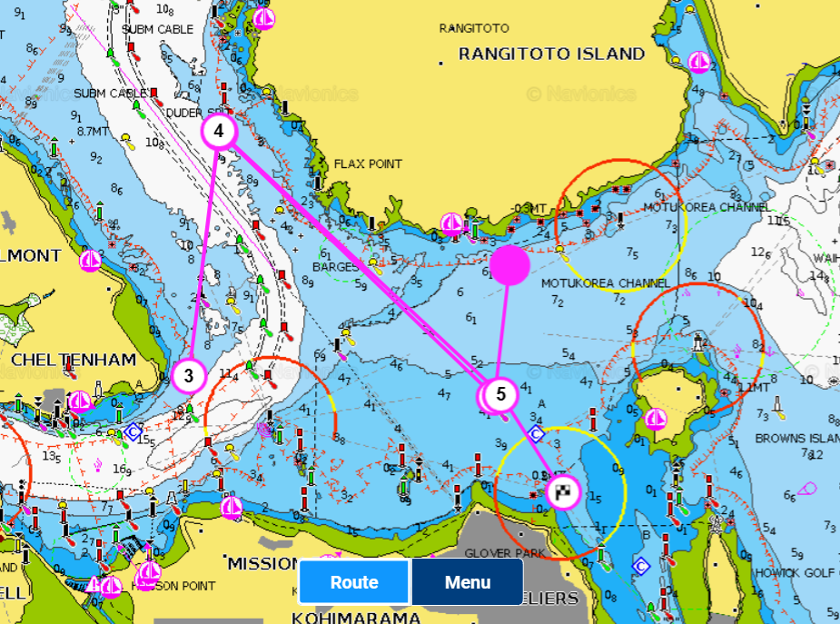

**NOT FOR NAVIGATION!! COURSES ARE APPROXIMATE!!**

**Course 22,** 13.5nm. start to mark 1 variable, mark 1 to 2 005°m mark 2 to 3 056°m mark 3 to 4 176°m mark 5 to 6 284°m mark 5 to 6 234°m mark 6 to 7 005°m mark 7 to 8 245°m mark 8 to 9 to finish 120°m.

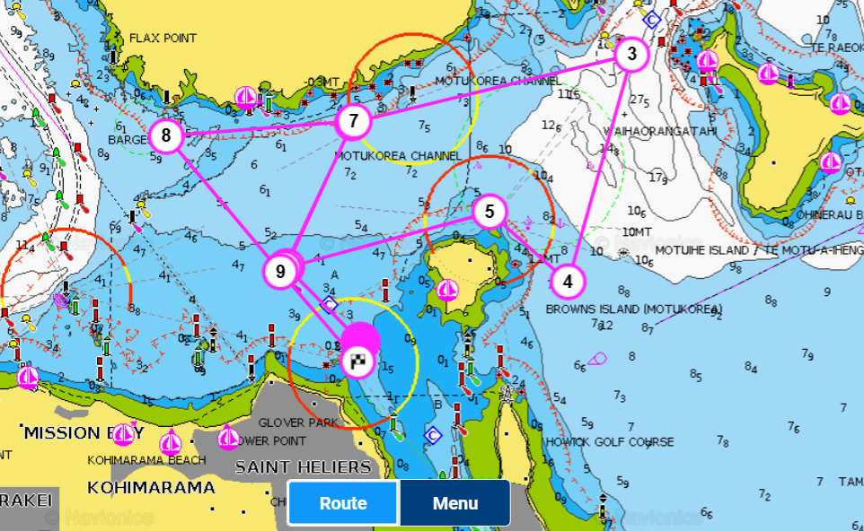

**NOT FOR NAVIGATION!! COURSES ARE APPROXIMATE!!**

**Course 23,** 13.4nm. start to mark 1 variable, mark 1 to 2 054°m mark 3 to 4 356°m mark 4 to 5 237°m mark 5 to 6 184°m mark 6 to 7 298°m mark 7 to 8 065°m mark 8 to 9 184°m to finish.

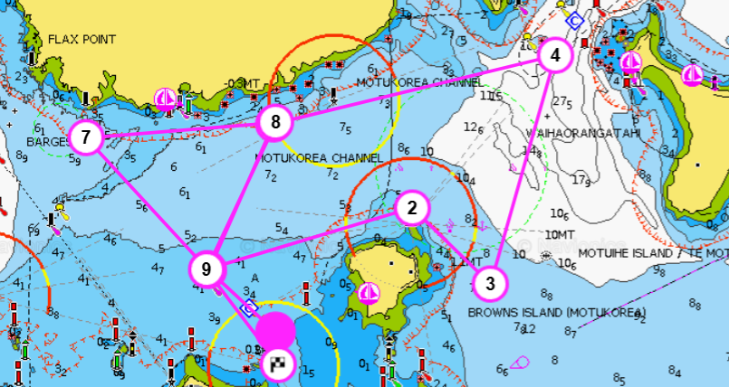

**NOT FOR NAVIGATION!! COURSES ARE APPROXIMATE!!**

**Course 24,** 14nm. start to mark 1 variable, mark 1 to 2 297°m mark 2 to 3 066°m mark 3 to 4 232°m mark 4 to 5 074°m mark 5 to 6 297°m mark 6 to 7 056°m mark 7 to 8 186°m to finish.

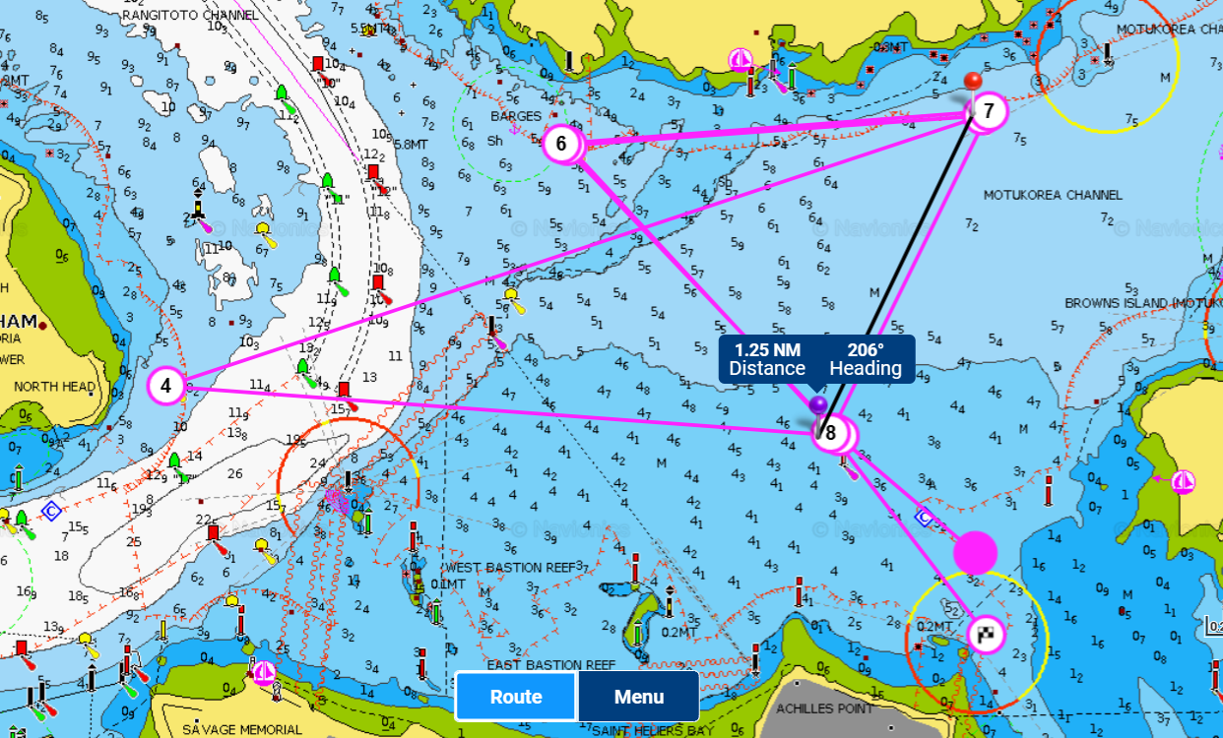

**Course 25,** 14nm. start to mark 1 variable, mark 1 to 2 254°m mark 2 to 3 050°m mark 3 to 4 247°m mark 4 to 5 116°m mark 5 to 6 004°m mark 6 to 7 246°m mark 7 to 8 to finish 119°m. Last mark Motukorea to port. 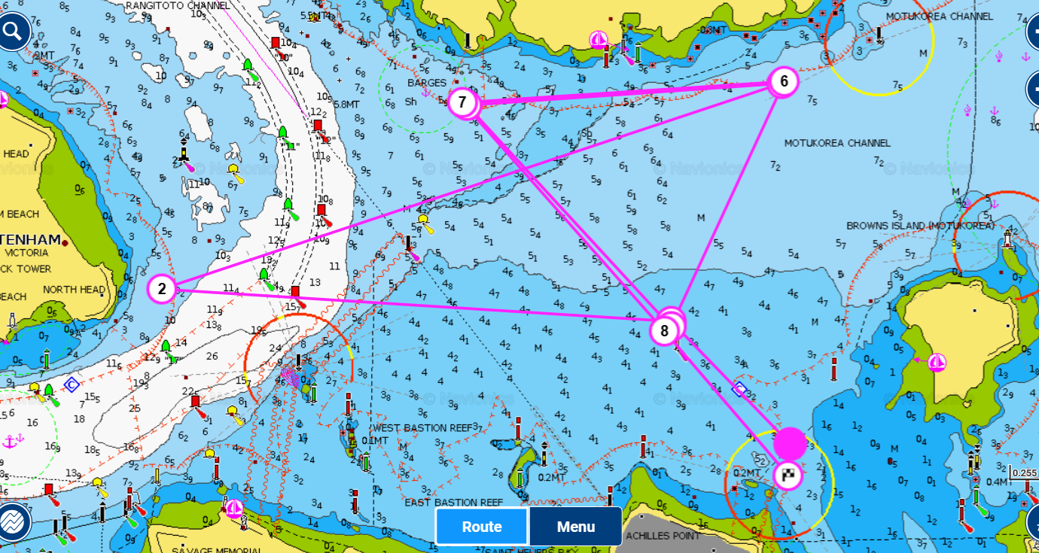

**NOT FOR NAVIGATION!! COURSES ARE APPROXIMATE!!**

**Course 26,** 12.7nm. start to Motuihe Island. Boats my take in any direction. To Motukorea to finish.

